MASSACHUSETTS,
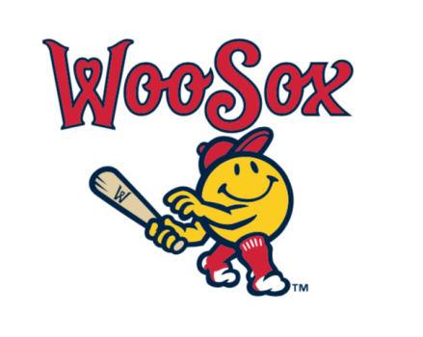
KNIGHTS OF COLUMBUS DAY AT POLAR PARK

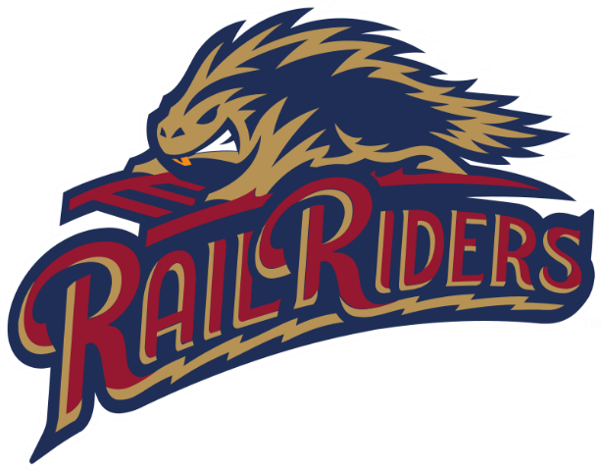

FRIDAY, JULY 18, 2025
6:45 PM $55.00 A TICKET, CENTERFIELD PRIVATE SECTION, INCLUDED-ALL-YOU-CAN-EAT
COME JOIN YOUR BROTHER KNIGHTS AND THEIR FAMILIES AS WE ENJOY A WOOSOX GAME AT POLAR PARK IN WORCESTER WITH FIREWORKS AFTER
JOIN STATE DEPUTY ROBERT SCHWARZ,
AND THE STATE OFFICERS
LIMITED TICKETS FIRST 75 PEOPLE.
CALL THE STATE OFFICE 781-551-0628

