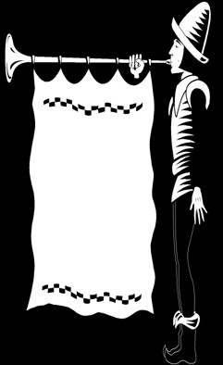

Past State Officers’ Dinner

Massachusetts State Council Knights of Columbus

470 Washington Street Suite #6

Norwood, MA 02062

Please accept my reservation for the Seventy-third Annual Past State Officers’ Dinner to be held on Thursday, June 26, 2025, at the Envision Hotel Mansfield, 31 Hampshire Street, Mansfield, MA. The reception is 6 PM with dinner served at 7 PM. Enclosed is my check for $50.00 to complete my reservation.

Name ________________________________________________________________

Address_______________________________________________________________

City/Town_____________________________ Zip ___________________________

Please make your check payable to the MA State Council K of C. Your reservation is sufficient to hold a seat, no tickets will be issued.

Please provide the following Information

1. No. years a member of the Order _________________________________
2. State Offices held ________________________________________
3. Dates of such offices _________________________________________
4. Council # _________________________________________