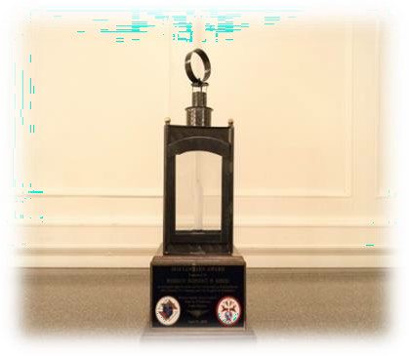

Join Us for the

One Hundred Twenty-Third Annual Patriot’s Day Dinner and the

Sixty-Seventh Annual Presentation of “*The Lantern Award*”

as we honor

Pope St. John XXlll Seminary

Very Reverend Brian R. Kiely, Rector/President

Monday, April 21, 2025

The Sheraton Framingham Hotel & Conference Center 1657 Worcester Road

Framingham, MA 01701

Cocktail Reception: 6:00-7:00 pm Dinner & Program ~ 7:00 pm

Name of Person/Council:__ _______________________________________________________________ Council Number: _________________________________________________________________________ Contact Name:___________________________________ Tel. Number:____________________________ Address:__________________________________________________________________________________

___________________________________________________________________________________________

Number of Tickets:

_________ @ $65.00 Total:

$_________________

Table of 10:___________ @ $650.00 Total: $_________________

Massachusetts State Knights of Columbus 470 Washington Street, Norwood, MA 02062