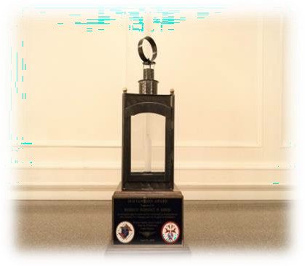
Join Us for the
One Hundred Twenty-Second Annual Patriot’s Day Dinner and the
Sixty-Sixth Annual Presentation of “The Lantern Award”
as we honor

Retired Master Sargent Dennis Mills
Location Leader for Wreaths Across America
At Bourne National Cemetery
Monday, April 15, 2024
The Sheraton Framingham Hotel & Conference Center 1657 Worcester Road
Framingham, MA 01701
Cocktail Reception: 6:00-7:00 pm Dinner & Program ~ 7:00 pm

Name of Person/Council:__ _______________________________________________________________ Council Number: _________________________________________________________________________ Contact Name:___________________________________ Tel. Number:____________________________ Address:__________________________________________________________________________________
___________________________________________________________________________________________

Number of Tickets:
_________ @ $65.00 Total:
$_________________

Table of 10:___________ @ $650.00 Total: $_________________
Massachusetts State Knights of Columbus 470 Washington Street, Norwood, MA 02062

